**Java Swing application**

**that analyzes statistical data and represents a graph based on user input for the X and Y axes (in this case, employment statistical growth for a country)**

you can use Java Swing for the user interface and JFreeChart for generating the graph.

Github link: [**https://github.com/himanshuSinghworkPort/java_swing_application_employement_growth_analysis**](https://github.com/himanshuSinghworkPort/java_swing_application_employement_growth_analysis)

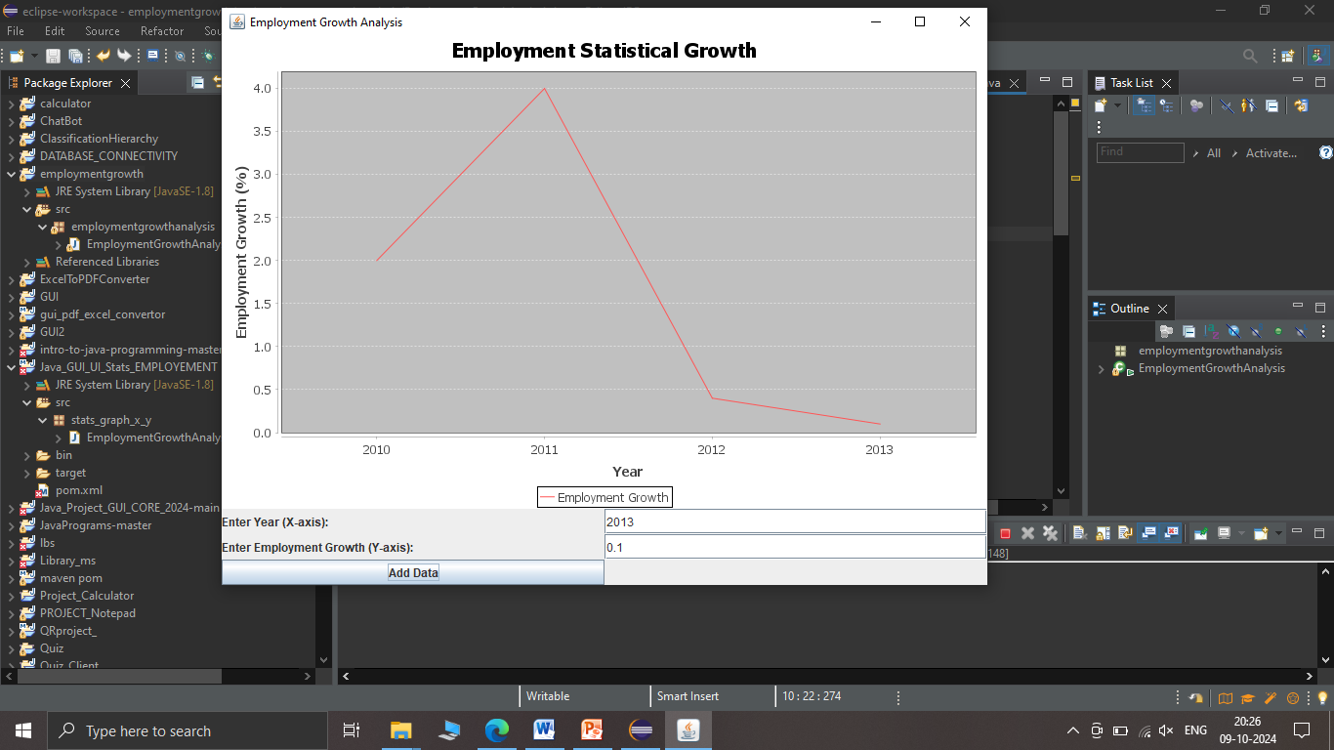

Project name:Java_GUI_UI_Stats_EMPLOYEMENT

Package name:stats_graph_x_y

Class name: **EmploymentGrowthAnalysis**

**Open eclipse>> create MAVEN PROJECT**

For maven projects there is pom.xml file

**Edit it and add>>**

**Set up Maven (optional but recommended):**

**If you're using Maven to manage dependencies, add JFreeChart to your pom.xml:**

**<dependency>**

**<groupId>org.jfree</groupId>**

**<artifactId>jfreechart</artifactId>**

**<version>1.5.3</version>**

**</dependency>**

**Or add jar files manually:**

#### Add JFreeChart Manually

1. Download JFreeChart from SourceForge JFreeChart.
2. Extract the ZIP file and locate the jfreechart-x.x.x.jar and jcommon-x.x.x.jar files.
3. In Eclipse, right-click on your project and select **Build Path** -> **Configure Build Path**.
4. Click on the **Libraries** tab and then **Add External JARs**.
5. Select both the jfreechart and jcommon JAR files you downloaded.
6. Click **Apply** and **Close**.

**Java source code:**

**import org.jfree.chart.ChartFactory;**

**import org.jfree.chart.ChartPanel;**

**import org.jfree.chart.JFreeChart;**

**import org.jfree.chart.plot.PlotOrientation;**

**import org.jfree.data.category.DefaultCategoryDataset;**

**import javax.swing.*;**

**import java.awt.*;**

**import java.awt.event.ActionEvent;**

**import java.awt.event.ActionListener;**

**public class EmploymentGrowthAnalysis extends JFrame**

**{**

**private JTextField xField;**

**private JTextField yField;**

**private DefaultCategoryDataset dataset;**

**public EmploymentGrowthAnalysis()**

**{**

**setTitle("Employment Growth Analysis");**

**setSize(800, 600);**

**setDefaultCloseOperation(JFrame.EXIT_ON_CLOSE);**

**setLayout(new BorderLayout());**

**// Input Panel**

**JPanel inputPanel = new JPanel();**

**inputPanel.setLayout(new GridLayout(3, 2));**

**inputPanel.add(new JLabel("Enter Year (X-axis): "));**

**xField = new JTextField();**

**inputPanel.add(xField);**

**inputPanel.add(new JLabel("Enter Employment Growth (Y-axis): "));**

**yField = new JTextField();**

**inputPanel.add(yField);**

**JButton addButton = new JButton("Add Data");**

**inputPanel.add(addButton);**

**// Graph Panel**

**dataset = new DefaultCategoryDataset();**

**JFreeChart chart = ChartFactory.createLineChart(**

**"Employment Statistical Growth",**

**"Year",**

**"Employment Growth (%)",**

**dataset,**

**PlotOrientation.VERTICAL,**

**true, true, false);**

**ChartPanel chartPanel = new ChartPanel(chart);**

**add(chartPanel, BorderLayout.CENTER);**

**add(inputPanel, BorderLayout.SOUTH);**

**// Add Button Action Listener**

**addButton.addActionListener(new ActionListener() {**

**@Override**

**public void actionPerformed(ActionEvent e) {**

**String year = xField.getText();**

**String growth = yField.getText();**

**if (!year.isEmpty() && !growth.isEmpty()) {**

**try {**

**double growthValue = Double.parseDouble(growth);**

**dataset.addValue(growthValue, "Employment Growth", year);**

**} catch (NumberFormatException ex) {**

**JOptionPane.showMessageDialog(null, "Please enter a valid number for employment growth.");**

**}**

**} else {**

**JOptionPane.showMessageDialog(null, "Please enter both Year and Employment Growth.");**

**}**

**}**

**});**

**}**

**public static void main(String[] args) {**

**SwingUtilities.invokeLater(() -> {**

**EmploymentGrowthAnalysis app = new EmploymentGrowthAnalysis();**

**app.setVisible(true);**

**});**

**}**

**}**

### Explanation of Code:

1. **Libraries**:
   * We use JFreeChart to create and display a line chart.
2. **User Interface**:
   * A form with two fields: one for inputting the year (X-axis) and one for the employment growth percentage (Y-axis).
   * A "Add Data" button that allows users to submit the values and update the graph.
3. **Graph Generation**:
   * The JFreeChart library generates the line chart based on the values added to the dataset.
   * The dataset.addValue() method adds data to the chart dynamically when the user inputs values and clicks the button.

### Steps to Run:

1. **Download the JFreeChart Library** if you are not using Maven, and add it to your classpath: JFreeChart download.
2. Compile and run the code. When the application starts, enter the year and employment growth rate, and press "Add Data" to plot the graph.

Ctrl+ Alt+ x

